

**Name:** Md. Rifat Ahmed

**ID:** 1931725042

**Course:** CSE311

**Section:** 9

# DATABASE PROJECT

## **Submitted To:** Nadeem Ahmed

**INDEX:**

Project Topic ------------------------------------------------------------------ Page 3

Project Description ---------------------------------------------------------- Page 3

ER Diagram -------------------------------------------------------------------- Page 5

Schema Diagram ------------------------------------------------------------- Page 6

Queries ------------------------------------------------------------------------- Page 7

Appendix:

Creating Database & Tables -------------------------------------- Page 15

Data Insertion -------------------------------------------------------- Page 16

**Project Topic: Blood Bank**

There are Blood Banks in most of the cities. Their purpose is to store bloods by collecting them from donors and then provide them to the patients that needs them. Some blood types are rare and cannot be found easily and that’s when a blood banks comes to the rescue because its job is to store all type of bloods from the donors.

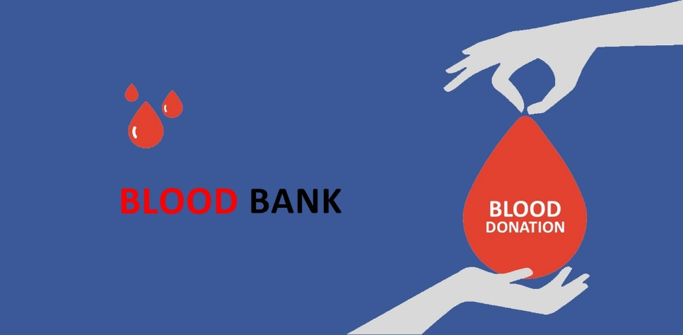

**Project Description:**

So, in this project my goal is to create a database for a Blood Bank where it’ll have the information of the Patients who requested blood and an entity - ‘Requests’ telling us by when they need the blood and how much. There’ll be another entity for the data of the blood issued to different patients. Then it’ll have the information of the donors who donated blood but they can choose not to provide their name, location or contact number. And finally, it’ll also have the information about all the donation histories like which donor donated blood, when and how much they donated.

**Entities and their Attributes:**

**Location** (LocationID, StreetAddress, PostalCode, City, State, CountryCode)

**Storage** (BloodGroup, Amount)

**Patient** (PatientID, Name, Age, Gender, LocationID, BloodGroup, ContactNo)

**Requests** (ReqNo, PatientID, NeededBy, Amount)

**Issued** (IssueRefNo, ReqNo, IssuedTo, IssueDate)

**Donor** (DonorID, Name, Age, Gender, LocationID, BloodGroup, ContactNo)

**Donation_History** (DonationNo, DonorID, Amount, DonationDate)

**Entities and their Relationships:**

A patient has a single type of blood group but a blood group can be found in many patients.

**Patient-Storage** (M:1)

A patient comes from a specific area (location) but from that location many patients might come.

**Patient-Location** (M:1)

A patient can make one request but a request cannot be made from different patients.

**Patient-Requests** (1:1)

A request made by a patient can be issued once however a request cannot be issued multiple times.

**Requests-Issued** (1:1)

A donor has a single type of blood group but a blood group can be found in many donors.

**Donor-Storage** (M:1)

A donor comes from a specific area (location) but from that location many donors might come.

**Donor-Location** (M:1)

A donor might make multiple donations in different times and a donation cannot be made by multiple donors.

**Donor-Donation_History** (1:M)

**ER Diagram:**

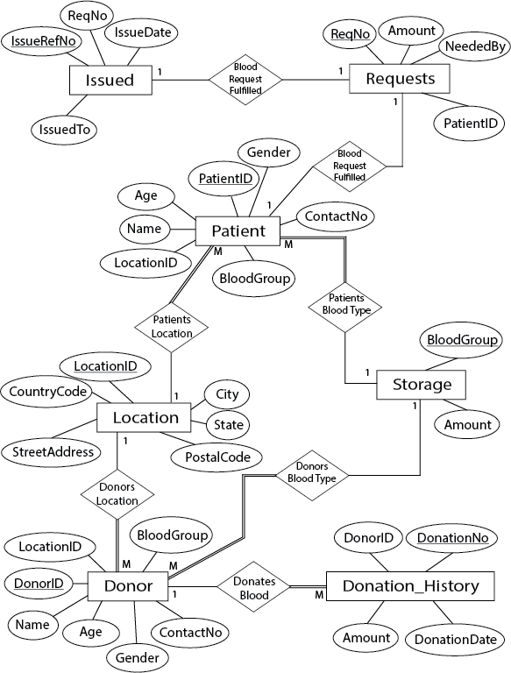

**Schema Diagram:**

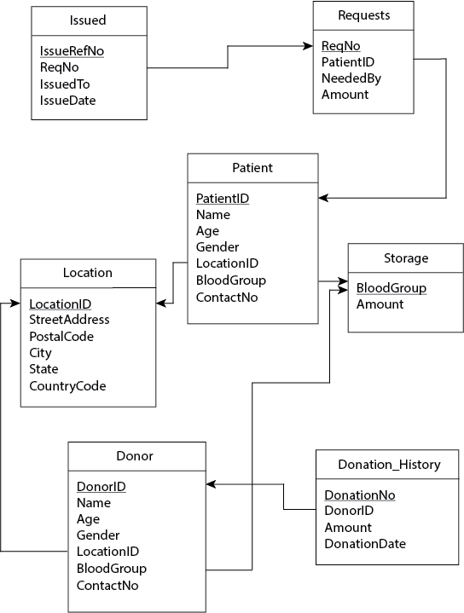

**Queries:**

**Q. Show all those Patients ID and Name who has the ‘O-’ blood.**

**Ans.**

select PatientID, Name

from Patient

where BloodGroup = 'O-'

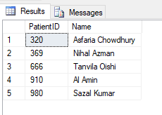

**Q. Show all those Patients ID and Name who has the ‘O-’ blood and are below the age of 40.**

**Ans.**

select PatientID, Name

from Patient

where BloodGroup = 'O-'

and Age < 40

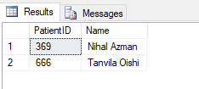

**Q. Fint the names of all those patients who are older in age than some patients with ‘AB+’ blood group.**

**Ans.**

select distinct P1.Name

from Patient as P1, Patient as P2

where P1.Age > P2.Age and P2.BloodGroup = 'AB+'

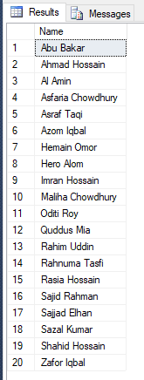

**Q. Find the names of all those Patients whose name includes the substring ‘hos’.**

**Ans.**

select Name

from patient

where Name like '%hos%'

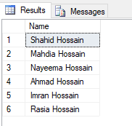

**Q. Display all those donors name in alphabetical order who are under the age of 22.**

**Ans.**

select Name

from Donor

where Age < 22

order by Name

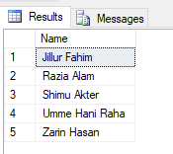

**Q. Show all those Patients ID and Name who has the ‘O-’ blood and are below the age of 40.**

**Ans.**

select Name

from Donor

where Age between 18 and 25

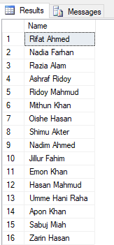

**Q. Show all those donors ID who donated blood in May and June month.**

**Ans.**

(select DonorID

from Donation_History

where MONTH(DonationDate) = '05')

UNION

(select DonorID

from Donation_History

where MONTH(DonationDate) = '06')

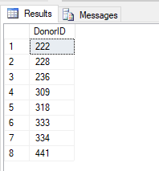

**Q. Find all those Donors ID and Name whose contact number is null.**

**Ans.**

select DonorID, Name

from Donor

where ContactNo is null

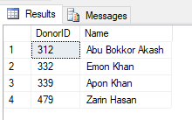

**Q. Show the average age of the Patients with ‘AB+’ blood and rename the column to Average Age of AB+ Patients.**

**Ans.**

select AVG(Age) as 'Average Age of AB+ Patients'

from Patient

where BloodGroup = 'AB+'

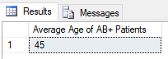

**Q. Count the total number of requests for blood made by the patients.**

**Ans.**

select COUNT(*)

from Requests

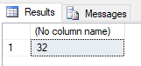

**Q. Find the average age of the patients for each type of blood group.**

**Ans.**

select BloodGroup, AVG(Age) as 'Avg Age'

from Patient

group by BloodGroup

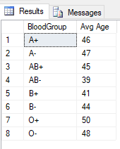

**Q. Find the total number of donors who donated more than 1 liter of blood.**

**Ans.**

select COUNT(distinct DonorID)

from Donation_History

where MONTH(DonationDate)

in (select MONTH(DonationDate)

from Donation_History

where Donation_History.Amount > 1)

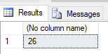

**Q. Find the average age of the patients for each type of blood group where the average age is higher than 45.**

**Ans.**

select BloodGroup, AVG(Age) as 'Avg Age'

from Patient

group by BloodGroup

having AVG(Age) > 45

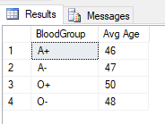

**Q. Find the average age of the patients for each type of blood group where the average age is higher than 45 using subquery.**

**Ans.**

select BloodGroup, Avg_Age

from (select BloodGroup, AVG(Age) as Avg_Age

from Patient

group by BloodGroup) as Avg_Age_Table

where Avg_Age > 45

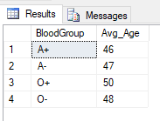

**Q. Show all the blood groups along with the number of patients having those blood groups.**

**Ans.**

select BloodGroup, (select COUNT(*)

from Patient

where Patient.BloodGroup = Storage.BloodGroup) as NoOfPatients

from Storage

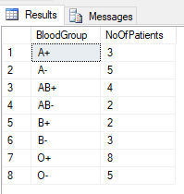

**Appendix:**

**Creating Database & Tables:**

Create Database Blood_Bank

Go

Use Blood_Bank

Go

Create Table Locations (

LocationID int constraint locID_pk primary key,

StreetAddress varchar(50),

PostalCode varchar(10) not null,

City varchar(25) not null,

State varchar(25),

CountryCode varchar(10) not null

)

Create Table Storage (

BloodGroup varchar(10) constraint bg_pk primary key,

Amount decimal(10,2)

)

Create Table Patient (

PatientID int constraint patID_pk primary key,

Name varchar(25) not null,

Age smallint not null,

Gender varchar(25) not null,

LocationID int,

BloodGroup varchar(10) not null,

ContactNo varchar(25) not null,

constraint patloc_fk foreign key (LocationID) references Locations (LocationID)

on delete cascade on update cascade,

constraint patbg_fk foreign key (BloodGroup) references Storage (BloodGroup)

)

Create Table Requests (

ReqNo int constraint reqNo_pk primary key,

PatientID int not null,

NeededBy date not null,

Amount decimal(10,2) not null,

constraint patID_fk foreign key (PatientID) references Patient (PatientID)

on delete cascade on update cascade

)

Create Table Issued (

IssueRefNo varchar(25) constraint issue_pk primary key,

ReqNo int not null,

IssuedTo varchar(25),

IssueDate date not null,

constraint reqNo_fk foreign key (ReqNo) references Requests (ReqNo)

on delete cascade on update cascade

)

Create Table Donor (

DonorID int constraint donID_pk primary key,

Name varchar(25),

Age smallint not null,

Gender varchar(25) not null,

LocationID int,

BloodGroup varchar(10) not null,

ContactNo varchar(25),

constraint donloc_fk foreign key (LocationID) references Locations (LocationID)

on delete cascade on update cascade,

constraint donbg_fk foreign key (BloodGroup) references Storage (BloodGroup)

)

Create Table Donation_History (

DonationNo int constraint donNo_pk primary key,

DonorID int not null,

Amount decimal(10,2) not null,

DonationDate date not null,

constraint donHis_fk foreign key (DonorID) references Donor (DonorID)

on delete cascade on update cascade

)

**Data Insertion:**

insert into Locations

values

(1300, 'Sher-e-bangla road', 1710, 'Tongi', 'Gazipur', 'BD'),

(1480, 'Gobib-e-newaz road', 2320, 'Uttara', 'Dhaka', 'BD'),

(1660, 'College gate chottor', 6600, 'Pabna', 'Rajshahi', 'BD'),

(1700, 'Choyonika garments road', 5643, 'Dhanmondi', 'Dhaka', 'BD'),

(2000, 'Matbor bari road', 9252, 'Dumuria', 'Khulna', 'BD'),

(2200, 'Chiringa bazar road', 4743, 'Coxs Bazar', 'Chittagong', 'BD'),

(2550, 'Bamon Borua road', 5530, 'Lal Matia', 'Chittagong', 'BD'),

(3300, 'Chowrasta', 3329, 'Panthapath', 'Dhaka', 'BD'),

(3600, 'Moulovi bazar boro road', 2460, 'Moulovi Bazar', 'Dhaka', 'BD'),

(3800, 'Munshi para road', 1100, 'Munshi Para', 'Gazipur', 'BD'),

(4000, 'Cherag Ali road', 1713, 'Tongi', 'Gazipur', 'BD'),

(4400, 'Abdur Rouf memorial road', 7330, 'Rangpur Sadar', 'Rangpur', 'BD'),

(4600, 'Shimla high school road', 5662, 'Mymenshing', 'Gazipur', 'BD'),

(4950, 'Kunia primary school road', 8720, 'Kunia', 'Rajshahi', 'BD'),

(5150, 'Dohar boro bazar', 1250, 'Narayanganj', 'Dhaka', 'BD'),

(5500, 'Shing ming chakma bari', 3930, 'Rangamati', 'Chittagong', 'BD'),

(5900, 'Ghat Par', 9790, 'Bashundhara R/A', 'Dhaka', 'BD'),

(6350, 'Shib Bari road', 3949, 'Gazipur Sadar', 'Gazipur', 'BD'),

(6600, 'Apollo road', 9792, 'Gulshan', 'Dhaka', 'BD'),

(6900, 'Tero hati boro road', 7770, 'Panchagram', 'Khulna', 'BD'),

(7700, 'Comilla bissho road', 9350, 'Comilla', 'Chittagong', 'BD'),

(8350, 'Dak bangla', 9340, 'Feni', 'Chittagong', 'BD')

insert into Storage

values

('O+', 66.50),

('O-', 27.25),

('A+', 53.70),

('A-', 41.99),

('B+', 79.45),

('B-', 48.90),

('AB+', 45.45),

('AB-', 35.80)

insert into Patient

values

(679, 'Maliha Chowdhury', 47, 'Female', 2550, 'A+', '+8801731561645'),

(750, 'Ahmad Hossain', 55, 'Male', 4950, 'A+', '+8801866500975'),

(111, 'Shahid Hossain', 45, 'Male', 5900, 'B+', '+8801547542552'),

(760, 'Imran Hossain', 69, 'Male', 5150, 'O+', '+8801544364884'),

(231, 'Hemain Omor', 49, 'Male', 1300, 'A-', '+8801954431257'),

(669, 'Asraf Taqi', 47, 'Male', 6350, 'AB+', '+8801305666535'),

(852, 'Rasia Hossain', 45, 'Female', 2200, 'O+', '+8801369755824'),

(732, 'Fredaus Zannat', 31, 'Female', 8350, 'O+', '+8801756532358'),

(991, 'Zafor Iqbal', 50, 'Male', 1480, 'A-', '+8801645443164'),

(730, 'Syed Rasel', 39, 'Male', 4400, 'O+', '+8801465645644'),

(675, 'Quddus Mia', 60, 'Male', 5900, 'B-', '+8801321659872'),

(987, 'Rahim Uddin', 54, 'Male', 2550, 'O+', '+8801654643131'),

(666, 'Tanvila Oishi', 30, 'Female', 3300, 'O-', '+8801556445363'),

(369, 'Nihal Azman', 36, 'Male', 3800, 'O-', '+8801765653227'),

(258, 'Azom Iqbal', 46, 'Male', 1660, 'AB+', '+8801542455464'),

(495, 'Rahnuma Tasfi', 60, 'Female', 2000, 'O+', '+8801416465193'),

(491, 'Hasan Mahmud', 37, 'Male', 4000, 'A+', '+8801654464622'),

(320, 'Asfaria Chowdhury', 65, 'Female', 3600, 'O-', '+8801829697190'),

(980, 'Sazal Kumar', 56, 'Male', 2200, 'O-', '+8801445664549'),

(770, 'Muhammad Shahidi', 38, 'Male', 1700, 'B+', '+8801646451124'),

(239, 'Hero Alom', 49, 'Male', 4600, 'A-', '+8801659464211'),

(444, 'Esrat Era', 40, 'Female', 5500, 'B-', '+8801987214533'),

(272, 'Nayeema Hossain', 42, 'Female', 6350, 'AB+', '+8801855644121'),

(141, 'Abu Bakar', 47, 'Male', 5900, 'AB+', '+8801989946464'),

(119, 'Mahdia Hossain', 33, 'Female', 7700, 'B-', '+8801864121284'),

(448, 'Mahiv Khan', 39, 'Male', 2000, 'AB-', '+8801544542254'),

(853, 'Asra Jahan', 40, 'Female', 6600, 'AB-', '+8801816546544'),

(910, 'Al Amin', 55, 'Male', 8350, 'O-', '+8801454346544'),

(600, 'Moumi Roy', 37, 'Female', 2200, 'A-', '+8801565645454'),

(100, 'Sajid Rahman', 52, 'Male', 7700, 'A-', '+8801646855989'),

(221, 'Sajjad Elhan', 57, 'Male', 4600, 'O+', '+8801465476586'),

(973, 'Oditi Roy', 50, 'Female', 6900, 'O+', '+8801677874544')

insert into Requests

values

(3941, 679, '2021-06-15', 2.50),

(4058, 750, '2021-07-02', 2.00),

(5966, 111, '2021-05-28', 1.50),

(6002, 760, '2021-05-07', 2.00),

(5015, 231, '2021-06-09', 2.25),

(5244, 669, '2021-07-20', 2.75),

(5578, 852, '2021-06-01', 2.50),

(5559, 732, '2021-08-14', 1.00),

(5693, 991, '2021-07-20', 2.25),

(5010, 730, '2021-05-27', 2.50),

(5228, 675, '2021-05-24', 3.00),

(5749, 987, '2021-06-04', 3.00),

(5661, 666, '2021-07-18', 2.00),

(5928, 369, '2021-06-04', 2.00),

(5546, 258, '2021-08-01', 2.50),

(5864, 495, '2021-09-20', 3.50),

(5441, 491, '2021-08-11', 2.00),

(5157, 320, '2021-07-07', 4.00),

(5357, 980, '2021-05-26', 3.25),

(5092, 770, '2021-08-09', 3.00),

(5662, 239, '2021-06-27', 1.50),

(5355, 444, '2021-07-15', 1.75),

(5704, 272, '2021-05-23', 1.00),

(5937, 141, '2021-06-13', 2.25),

(5529, 119, '2021-07-30', 1.00),

(5367, 448, '2021-06-07', 2.00),

(5158, 853, '2021-05-29', 2.50),

(5142, 910, '2021-08-01', 3.25),

(5074, 600, '2021-06-02', 1.75),

(5339, 100, '2021-06-11', 2.50),

(5716, 221, '2021-08-20', 3.50),

(5821, 973, '2021-05-30', 2.00)

insert into Issued

values

('39HF3M', 3941, 'Patients Husband', '2021-06-12'),

('749ES4', 5966, 'Patients Brother', '2021-05-26'),

('69FG31', 6002, 'Patients Son', '2021-05-05'),

('3JK6S3', 5578, 'Patients Husband', '2021-05-30'),

('24GG71', 5010, 'Patients Brother', '2021-05-26'),

('65DJW3', 5228, 'Patients Daughter', '2021-05-22'),

('354D2G', 5749, 'Patients Wife', '2021-06-03'),

('3G3G2D', 5928, 'Patients Sister', '2021-06-03'),

('4G5A45', 5546, 'Patients Wife', '2021-07-29'),

('64FF31', 5357, 'Patients Son', '2021-05-25'),

('6GW3G4', 5662, 'Patients Brother', '2021-06-24'),

('7FG25F', 5704, 'Patients Husband', '2021-05-22'),

('1F5G74', 5937, 'Patients Brother', '2021-06-10'),

('8GD542', 5367, 'Patients Father', '2021-06-06'),

('5ED7G3', 5158, 'Patients Husband', '2021-05-28'),

('36HWY3', 5074, 'Patients Husband', '2021-06-01'),

('9GE65G', 5339, 'Patients Son', '2021-06-10'),

('69ATO2', 5821, 'Patients Daughter', '2021-05-30')

insert into Donor

values

(222, 'Rifat Ahmed', 22, 'Male', 4400, 'O+', '+8801795918449'),

(235, 'Rayhan Ahmed', 27, 'Male', 4400, 'O-', '+8801634866514'),

(236, 'Rizvi Ahmed', 30, 'Male', 4400, 'O-', '+8801943245155'),

(228, 'Nadia Farhan', 25, 'Female', 4950, 'A+', '+8801791641256'),

(229, 'Razia Alam', 21, 'Female', 1660, 'A+', '+8801952151155'),

(301, 'Ashraf Ridoy', 22, 'Male', 2000, 'B+', '+8801354894889'),

(302, 'Ridoy Mahmud', 22, 'Male', 4950, 'AB-', '+8801544849169'),

(308, 'Mithun Khan', 22, 'Male', 8350, 'B-', '+8801647717341'),

(309, 'Oishe Hasan', 23, 'Female', 1480, 'B+', '+8801782592282'),

(311, 'Shimu Akter', 21, 'Female', 2550, 'A+','+8801747717340'),

(312, 'Abu Bokkor Akash', 28, 'Male', 6600, 'O+', NULL),

(317, 'Nadim Ahmed', 23, 'Male', 3300, 'A+', '+8801777717348'),

(318, 'Jannatul Haque', 35, 'Female', 1700, 'AB+', '+8801647717834'),

(319, 'Jillur Fahim', 19, 'Male', 2200, 'O+', '+8801347717309 '),

(320, 'Rafiq Miah', 40, 'Male', 7700, 'AB+', '+8801839058729'),

(325, 'Sajida Khanom', 27, 'Female', NULL, 'O-', '+8801748817348'),

(326, 'Faria Mili', 27, 'Female', 4600, 'B-', '+8801533717348'),

(327, 'Jannatul Faria', 40, 'Female', 6900, 'B+', '+8801633317338'),

(330, 'Sabbir Ahmed', 35, 'Male', 4000, 'A+', '+8801947717388'),

(331, 'Abdul Kader', 37, 'Male', 1300, 'A+', '+88019782492289 '),

(332, 'Emon Khan', 24, 'Male', 5150, 'A+', NULL),

(333, 'Nadia Akter', 30, 'Female', 8350, 'A-', '+8801647517341'),

(334, 'Hasan Mahmud', 25, 'Male', 3800, 'B+', '+8801647717345'),

(336, 'Umme Hani Raha', 20, 'Female', 5500, 'O+', '+8801337705321'),

(338, 'Farin Tasnia', 26, 'Female', 6900, 'AB+', '+8801782492284'),

(339, 'Apon Khan', 23, 'Male', 1480, 'AB+', NULL),

(440, 'Asraf Uddin', 29, 'Male', 2200, 'B+', '+8801884489054'),

(441, 'Tanvir Ahmed', 33, 'Male', 5900, 'A+', '+8801541117111'),

(443, 'Sazzad Hossain', 28, 'Male', 6350, 'AB-', '+8801765492281'),

(445, 'Sabuj Miah', 24, 'Male', 3600, 'O-', '+8801307517345'),

(448, 'Hasnat Hossain', 31, 'Male', 1700, 'O+', '+8801333333331'),

(479, 'Zarin Hasan', 21, 'Female', 2200, 'O+', NULL)

insert into Donation_History

values

(1377, 222, 1.00, '2021-03-22'),

(1383, 235, 1.50, '2021-03-25'),

(1369, 308, 1.50, '2021-03-15'),

(1414, 319, 1.00, '2021-04-14'),

(1551, 309, 0.50, '2021-05-30'),

(1378, 236, 0.50, '2021-03-22'),

(1103, 332, 0.50, '2021-01-07'),

(1320, 440, 1.00, '2021-03-06'),

(1235, 448, 1.25, '2021-02-24'),

(1396, 338, 1.25, '2021-03-27'),

(1109, 326, 1.00, '2021-01-10'),

(1379, 228, 0.50, '2021-03-22'),

(1350, 325, 1.00, '2021-03-10'),

(1566, 333, 0.50, '2021-05-31'),

(1427, 311, 1.00, '2021-04-27'),

(1234, 229, 1.25, '2021-02-23'),

(1517, 318, 1.00, '2021-05-17'),

(1220, 479, 0.50, '2021-02-13'),

(1303, 325, 0.75, '2021-03-02'),

(1627, 222, 0.50, '2021-06-06'),

(1413, 301, 1.00, '2021-04-13'),

(1380, 326, 1.25, '2021-03-23'),

(1529, 441, 1.00, '2021-05-28'),

(1502, 334, 1.25, '2021-05-05'),

(1118, 302, 0.50, '2021-01-21'),

(1212, 320, 0.50, '2021-02-11'),

(1104, 330, 0.50, '2021-01-07'),

(1398, 443, 1.00, '2021-03-30'),

(1500, 228, 0.50, '2021-05-02'),

(1415, 339, 1.00, '2021-04-14'),

(1422, 312, 0.50, '2021-04-24'),

(1300, 330, 0.50, '2021-03-01'),

(1202, 443, 0.50, '2021-02-07'),

(1240, 336, 1.00, '2021-02-27'),

(1395, 327, 0.50, '2021-03-26'),

(1503, 236, 1.00, '2021-05-06'),

(1110, 445, 1.25, '2021-01-13'),

(1116, 317, 1.25, '2021-01-18'),

(1408, 331, 0.50, '2021-04-04'),

(1210, 235, 0.50, '2021-02-09')